Transcript of handwritten first and second letters:

9 Cromarty Street
Quirindi 2343

1 March 2016

NSW Chief Scientist and Engineer
GPO Box 5477
Sydney NSW 2000

Ma'am,

As many of our coal mines are in dry areas where it is impractical to wash the coal prior to transport and shipping.

As this coal is often dusty; ie: Werris Creek I do make the following suggestions.

Use a giant vacuum cleaner (designed) to vacuum this coal as it is travelling up the loader belt. I believe this will, in the main, eliminate the nuisance in coal train transport.

Collect this dust in receptacles (already designed) and perhaps use it in some of the following ways (all if possible).

Sell the dust to farmers for carbon addition to the soil instead of expensive and large wood consumption to produce charcoal. There is no need to refine or process the coal dust as eg: if dust has sulphur this could be applied to sulphur deficient soils and if high ash this provides essential potassium to the soil for plant growth.

Three local produce firms are very keen on this idea and would like it to happen.

Make briquettes and/or pellets from this dust to provide a more efficient and superior fuel for use in all solid fuel devices. This removes perhaps the need to cut down trees for wood for fuel.

Use the coal dust and/or pellets for the purification (partial of water) in place of activated carbon (charcoal) as the dust and pellets are certainly activated enough. Note that after this use, the coal dust and/or pellets may be used again as normal.

Use this product in place of charcoal (activated) to purify air. Note that this will reduce the cost (at present) as against activated charcoal very significantly.

Use this dust as a replacement for other oil hydrocarbons as a component of mine explosives used in the mine to provide a superior and less expensive explosive for mine use.

Use in all oil based fuels as a colloidal component; up to 40% by weight in petrol, diesel, heating oil etc. to provide a superior fuel for all internal combustion engines. Properly made, colloidal fuel is suitable for all liquid fuelled engines without any modifications to the engine and will provide more power than other commercially available fuels in all engines.

I have succeeded in making this fuel and am constructing a small plant for my own use in both petrol and diesel engined vehicles etc.

Note that this was done in the World Financial Crisis of the 1930s, during World War II, and after World War II in the catch up needed for oil production to match world needs.

There are quite a few unknowns etc. and this will require great teamwork to achieve, but we won't know until we try. As we have nothing to lose and everything to win, I am excited and motivated and I will be glad to discuss this further.

Subsequent correspondence received on 14 March 2016

I would add the following: - I am already using this coal dust as part of my gardening and hydroponics programme. It does work very well. I also can vouch for its removal of bad taste (ie: chlorine) as Werris Creek water is chlorinated and tastes really awful so I have tested this one with flying colours.

As a replacement for other oil hydrocarbons as a component of mine explosives has already been done successfully by some Queensland mines (our project manager at Werris Creek comes from Queensland and can verify this).

As a result of a lot of research I have succeeded in producing colloidal coal/petroleum fuels by a much more modern and effective method. This is known only to me at the moment.

I do propose to construct a small pelletizing plant for my own use and for research and larger just scaled up.
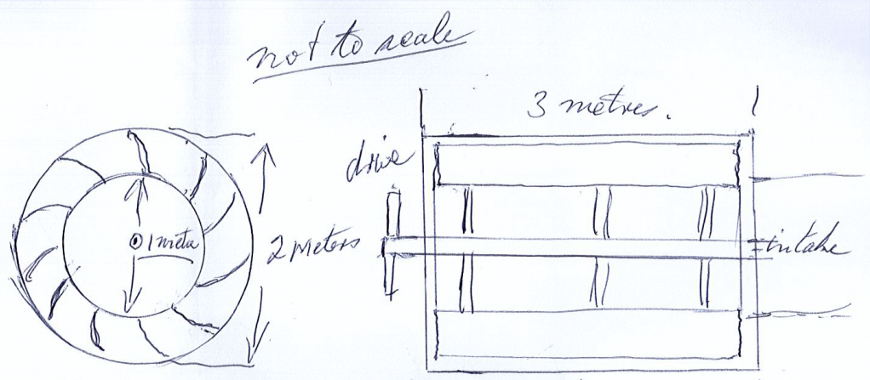

This comes from grain harvester technology, just a little more efficient and can be constructed in most mine and engineering workshop ie: Tamarang Engineering in Quirindi. As works at quite low R.P.M. and can be powered by an engine and clutch package including gearbox as available in good condition from most wrecking establishments (low cost has to be paramount). This can be mounted on a suitable trailer chassis; only large sedan or ute parts may be used (recycled if possible as the heaviest part is the engine power plant). Easily serviced by mine or local servicemen and can be towed by any ordinary vehicle or tractor. Once successful, could then be incorporated into the loader construction itself. As I do have access to the mine site, I am working with management on carefully estimated outcomes in tonnes per train load.

I would like to include my contact details on your website and you can publish my mobile and address.

I believe the exchange of ideas is very important as well as other peoples' expertise to add to the total.

Yours sincerely,
Lindsay Bridge 0431 319 302

